**CS5560**

**Knowledge Discovery and Management**

**Syed Jawad Shah**

**Project**

**Free Hand Sketch Recognition**

**Team: Delta**

Vanitha Kunta (16326099)

Manish Kumar Brungi (16323830)

Akhila Thotapalli (16322891)

Bhargav Santosh Areti (1633050)

**Objective:**

Humans have used sketching to depict our visual world since prehistoric times. Even today, sketching is possibly the most important rendering technique readily available to all humans. Sketching is one of the primary methods people use to communicate visual information.

Free-hand sketches are usually drawn by non-artists using touch sensitive devices rather than purpose-made equipment; thus, making them often highly abstract and exhibit large intraclass deformations. This makes automatic recognition of sketches more challenging than other areas of image classification because sketches of the same object can vary based on artistic style and drawing ability. In addition, sketches are less detailed and thus harder to distinguish than photographs.

The main aim of our project is to recognize the objects in free-hand sketches or drawings using a Convolutional Neural Network (CNN). The model is trained on a dataset of human-drawn images representing many different classes. Using a publicly available dataset of 20,000 sketches across 250 classes, we are applying CNN to improve performance to increase the recognition accuracy on sketches drawn by different people. Based on the computational model, we demonstrate an interactive sketch recognition system for a few objects.

**Description:**

**Dataset**

1. In this project, we used the Tu Berlin Dataset.
2. Tu Berlin dataset is a dataset of 20,000 gray scale images, labeled over 250 classes.
3. These images were collected from the source Cybertron.
4. This dataset has 250 classes containing 80 images each.
5. The different classes listed in the dataset are lion, snake, apple, banana, airplane, alarm clock, grapes, cow, pizza, elephant, cake, strawberry etc.,

**Data augmentation**

Since the dataset contains very less number of images in each class i.e., 80 for each class, we have performed data augmentation to generate more images for each class. Data Augmentation is a technique that can be used to artificially expand the size of a training set by creating modified data from the existing one. Data Augmentation is not only used to prevent overfitting. In general, having a large dataset is crucial for the performance of both ML and Deep Learning (DL) models. However, we can improve the performance of the model by augmenting the data we already have. It means that Data

Augmentation is also good for enhancing the model’s performance.

We used the **OpenCV** library to perform image augmentation.

Below are the image augmentation techniques that we used:

1. **Erosion**: Erosion is a morphological image processing operation. Morphological image processing basically deals with modifying geometric structures in the image. Morphological operations are a set of operations that process images based on shapes. They apply a structuring element to an input image and generate an output image. Erosion basically strips out the outermost layer of pixels in a structure. Erodes away the boundaries of the foreground object and it is used to diminish the features of an image.
2. **Mirroring**: Image mirroring is a process of creating a reversed copy of an image across the either vertical or horizontal axis. OpenCV library provides a flip() method to flip the image across the horizontal or vertical axis.
3. **Rotation**: Image rotation is a common image processing routine with applications in matching, alignment, and other image-based algorithms. Rotating simply rotates an image across different angles.
4. **Scaling**: Image resizing refers to the scaling of images. Scaling comes in handy in many image processing as well as machine learning applications. It helps in reducing the number of pixels from an image and that has several advantages e.g. It can reduce the time of training of a neural network as more is the number of pixels in an image more is the number of input nodes that in turn increases the complexity of the model. It also helps in zooming in images.

**Convolutional Neural Networks**

A Convolutional Neural Network (ConvNet/CNN) is a Deep Learning algorithm which can take in an input image, assign importance (learnable weights and biases) to various aspects/objects in the image and be able to differentiate one from the other. Convolutional Neural Networks are made up of neurons with learnable weights and biases, just as neural networks. Each neuron takes a weighted sum of many inputs, passes it through an activation function, and reacts with an output. The preprocessing required in a ConvNet is much lower as compared to other classification algorithms. While in primitive methods filters are hand-engineered, with enough training, ConvNets can learn these filters/characteristics.

The architecture of a ConvNet is analogous to that of the connectivity pattern of Neurons in the Human Brain and was inspired by the organization of the Visual Cortex. Individual neurons respond to stimuli only in a restricted region of the visual field known as the Receptive Field. A collection of such fields overlap to cover the entire visual area.

Convolutional neural networks are made up of two parts: the first is a convolutional base, which is a stack of changed convolutional and pooling layers, and the second is a densely connected classifier put on top of the convolutional base.

**VGG-16**

VGG-16 is a convolutional neural network (CNN) architecture that is thought to be an effective model for image categorization. It is a pre-trained model. A pre-trained model is a model that has been previously trained on a dataset and contains the weights and biases that represent the features of whichever dataset it was trained on. Learned features are often transferable to different data. For example, a model trained on a large dataset of bird images will contain learned features like edges or horizontal lines that would be transferable to your dataset.

The model achieves 92.7% top-5 test accuracy in ImageNet, which is a dataset of over 14 million images belonging to 1000 classes.

There are sixteen layers in this model.

13 layers of convolve

3 thick layers

We also have the Max-Pooling Layers, which helps to reduce the dimensionality of the data and allows for more accurate feature assumptions.

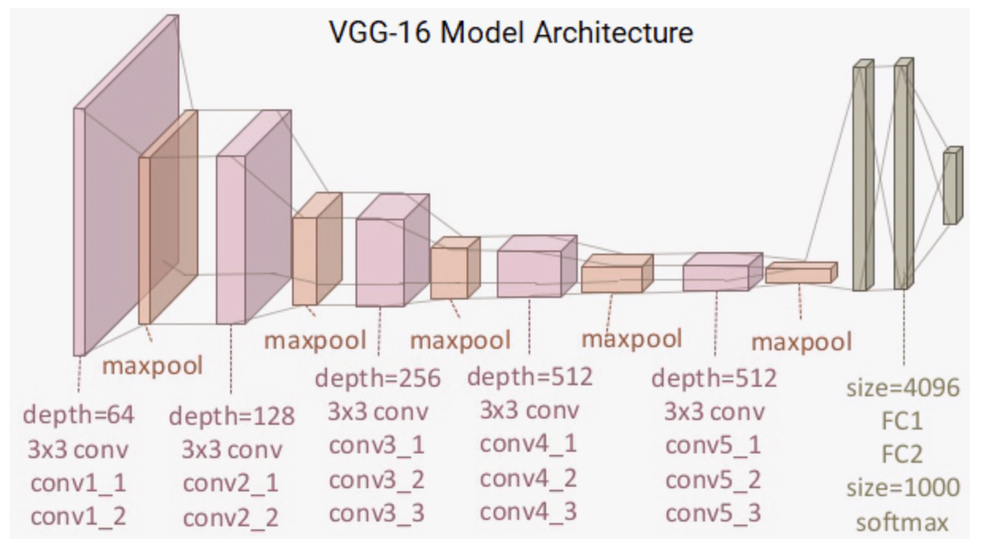

**Transfer learning**

Transfer learning is the process of taking a model that has been trained on a big dataset, such as ImageNet, and applying it to a new problem. This will necessitate less training data and allow for considerably faster training.

Transfer learning can be used in two ways:

1. Feature extraction
2. Fine-tuning

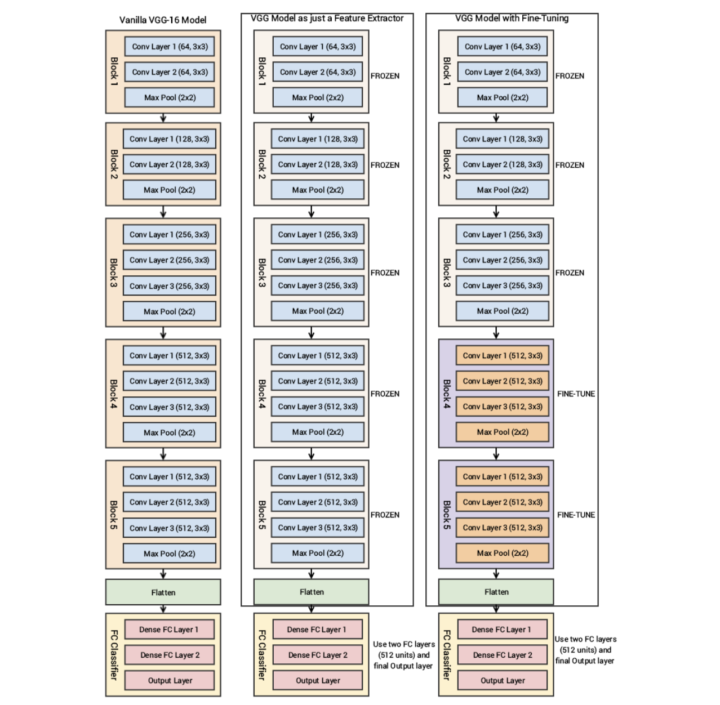

The process of feature extraction entails running the input photos through the base model and using the outputs to build a new classifier.

***Feature extraction*** can be done in one of two ways:

1. Remove the base model's head (in the case of the VGG19 model, the FC layers). Through the basic model, propagate the training data. Save the results to a NumPy array, a CSV file, or another format. To train a new classifier, use these outputs.
2. Alternatively, we can use feature extraction in the following way:

Remove the head from the model's foundation. On top of the original model, add a new classifier. Freeze the basic model's layers. The new classifier will need to be trained.

***Fine-tuning*** consists of unfreezing the top layers of the base model and retraining the network with a low learning rate. Fine-tuning should be done after feature extraction. To further improve the accuracy of the model, use fine-tuning. Fine-tuning should only be attempted after training the densely connected classifier that has been put on top of the convolutional base, since otherwise the weight updates would be too high, destroying the features gained by the fine-tuned layers.

There are two main factors that will affect the choice of transfer learning or fine tuning:

* The dataset size
* Similarity of the dataset to the pre-trained dataset (typically ImageNet)

1. *New dataset is small and similar to the original dataset:* Since the data is small, it is not a good idea to fine-tune the ConvNet due to overfitting concerns. Since the data is similar to the original data, we expect higher-level features in the ConvNet to be relevant to this dataset as well. Hence, the best idea might be to train a linear classifier on the CNN codes.
2. *New dataset is large and similar to the original dataset:* Since we have more data, we can have more confidence that we won’t overfit if we were to try to fine-tune through the full network.
3. *New dataset is small but very different from the original dataset:* Since the data is small, it is likely best to only train a linear classifier. Since the dataset is very different, it might not be best to train the classifier from the top of the network, which contains more dataset-specific features. Instead, it might work better to train the SVM classifier from activations somewhere earlier in the network.
4. *New dataset is large and very different from the original dataset:* Since the dataset is very large, we may expect that we can afford to train a ConvNet from scratch. However, in practice it is very often still beneficial to initialize with weights from a pretrained model. In this case, we would have enough data and confidence to fine-tune through the entire network.

**Implementation Steps:**

1. Downloaded the Tu Berlin Dataset and performed Data Augmentation
2. Uploaded the dataset to Drive and accessed it in Colab
3. We have tried training the model for the entire dataset, but the computing resources were insufficient. The RAM available in Google Colab was not enough to perform the operation and the session kept crashing.
4. So, we trained the model for two classes (apple and banana) by using the VGG16 model and applying transfer learning to it. So, the current model can recognize the given sketch as either apple or banana

**Implementation (code snippets & screenshots)**

1. **Data Augmentation:**
   1. Erosion:

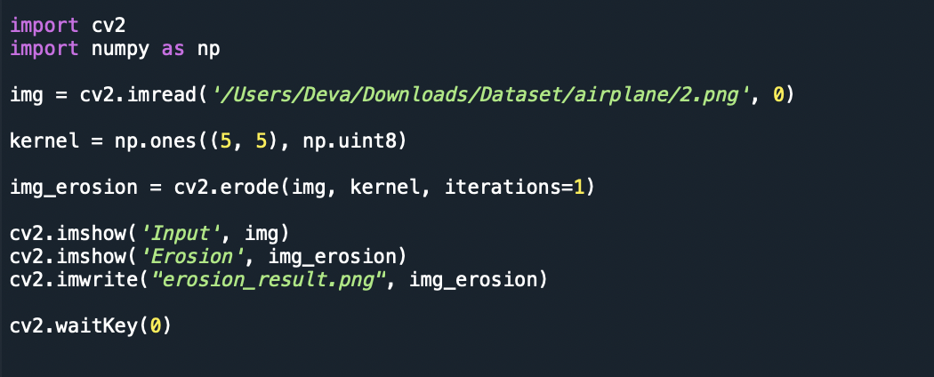

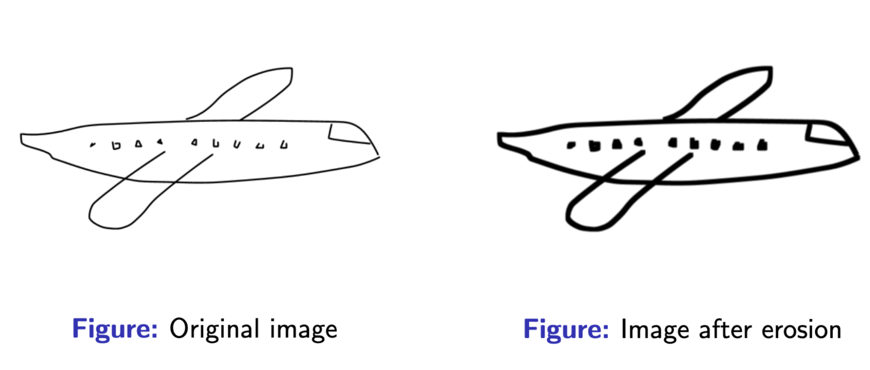

* 1. Mirroring:

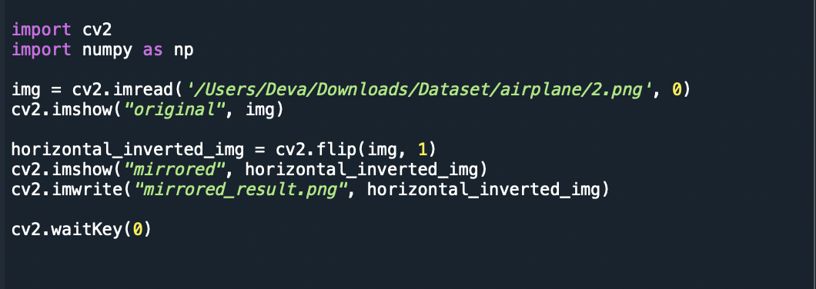

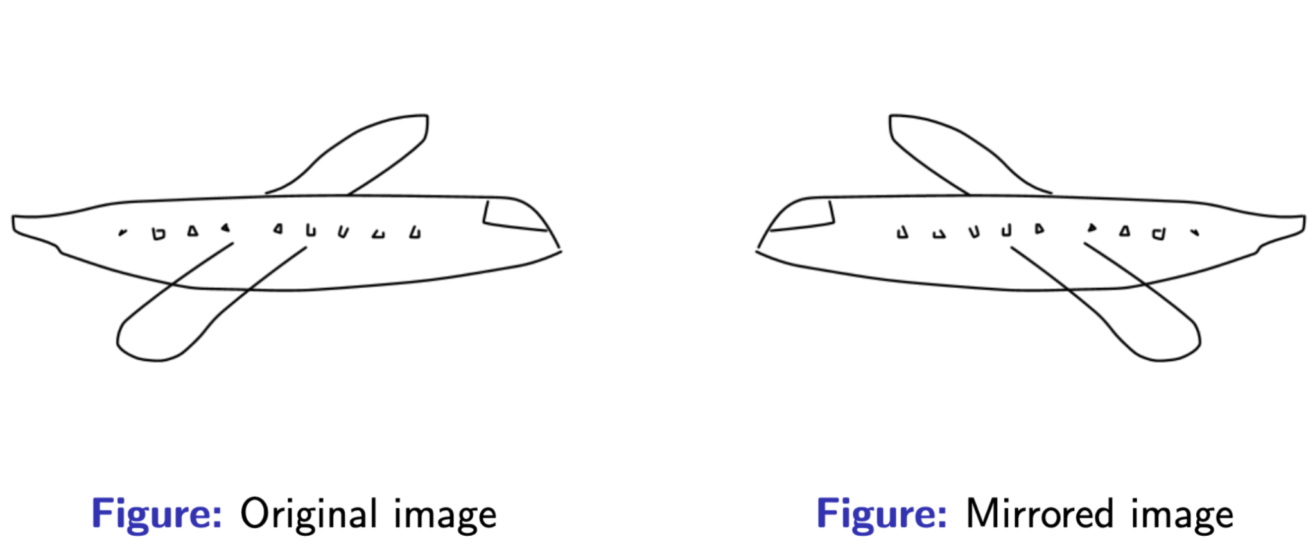

* 1. Rotating:

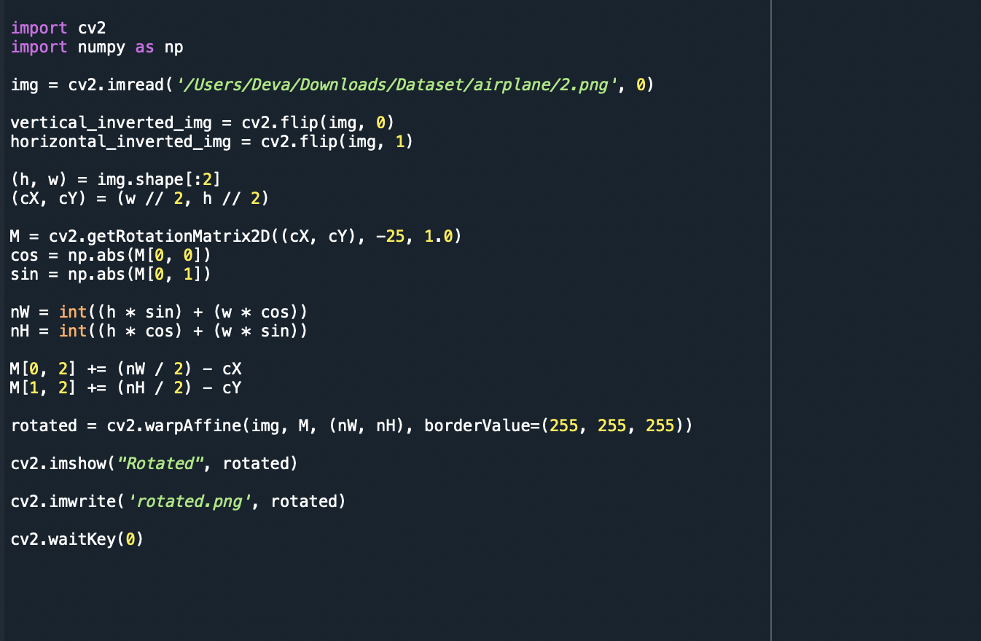

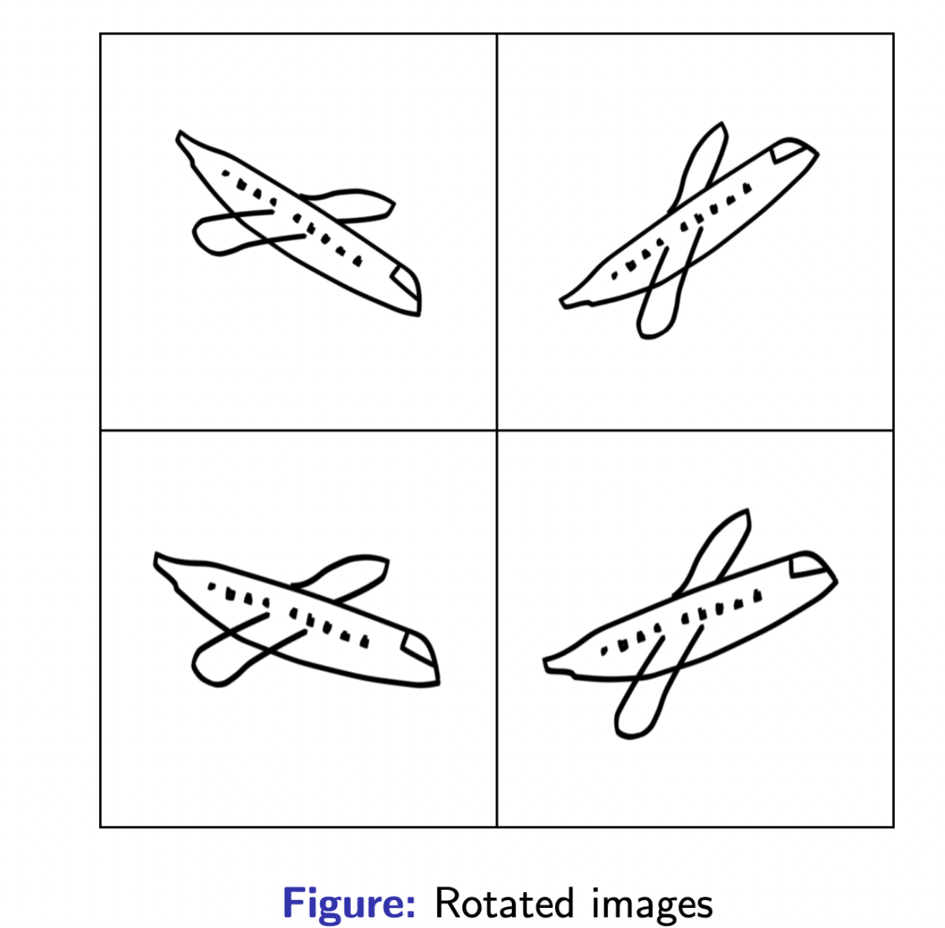

* 1. Scaling:

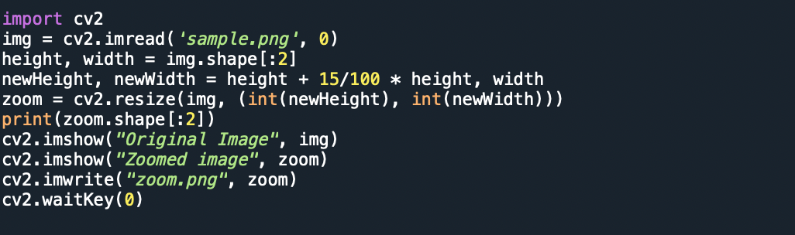

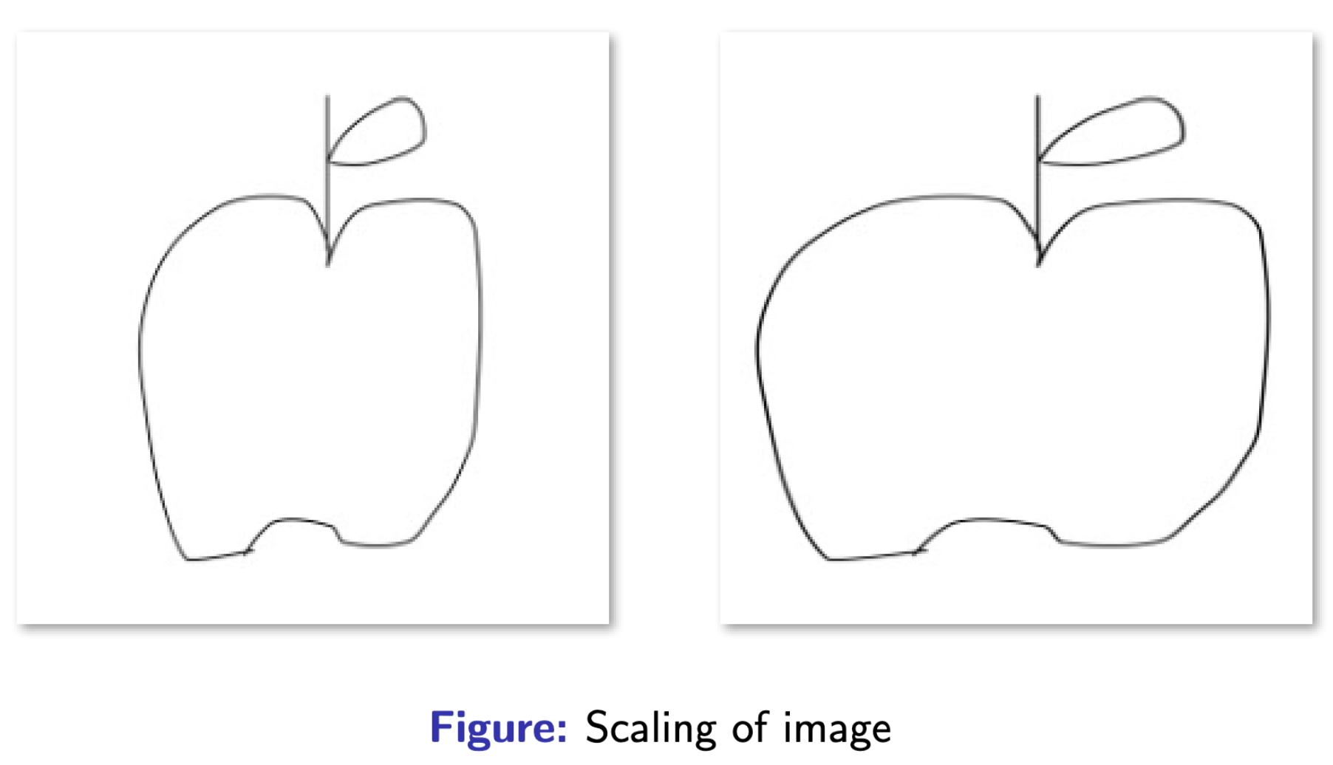

1. **Dataset Extraction:**

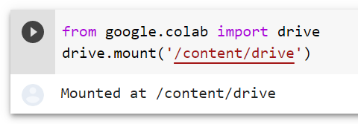

* drive.mount() is used to mount Drive in Colab

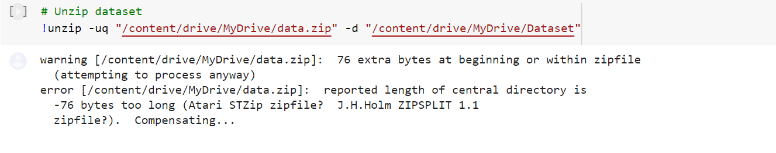

* Initially, the dataset is compressed and uploaded to Drive. The uploaded dataset has 160 categories each containing 960 images.
* We can unzip the dataset using the above command

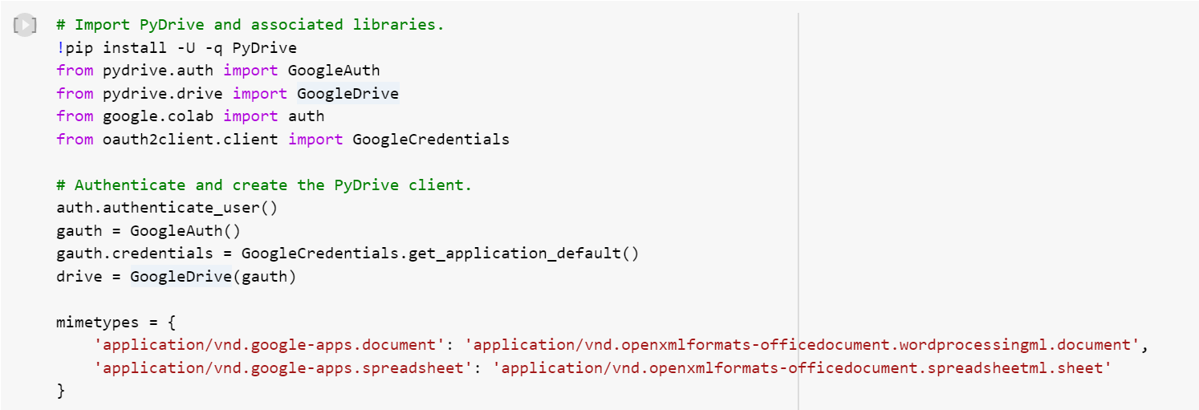

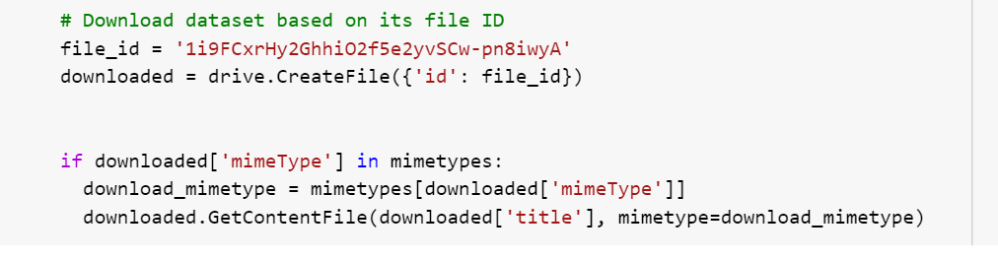

* PyDrive is a high-level Python wrapper for the Google Drive API. It allows you to easily upload, download, and delete files in your Google Drive from a Python script.
* We downloaded the dataset based on its file ID

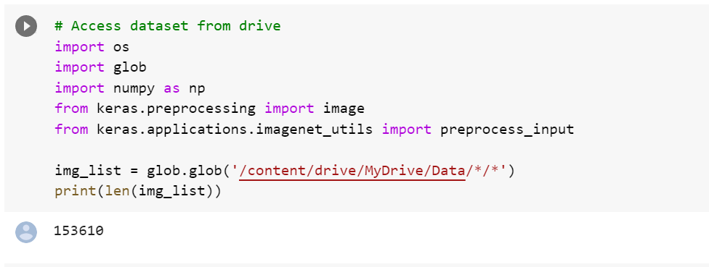

* glob (short for global) is used to return all file paths that match a specific pattern.
* Since the dataset is stored with the name Data in drive, the above command returns all the files that are there in the Data folder
* Here, the length of total images list is 153610

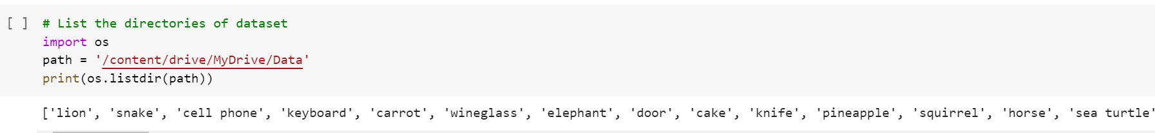

* os.listdir(path) is used to list all the directories which are there in the specified path
* So, the above command returns all the categories of the dataset

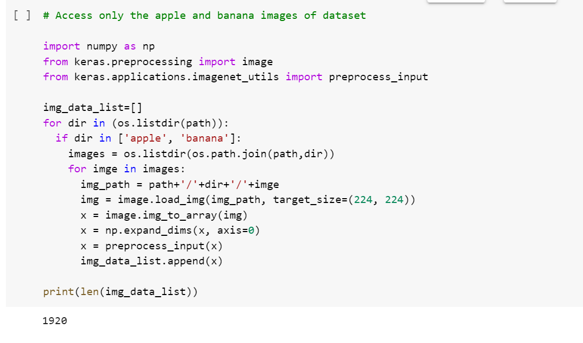

* The above code is used to access only the images of categories apple and banana from the dataset
* Since, there are 960 images in each category it returns 1920

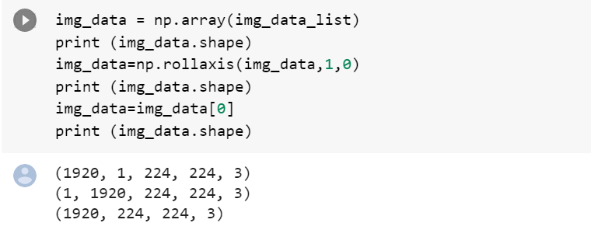

* A numpy array is a grid of values, all of the same type, and is indexed by a tuple of nonnegative integers. The number of dimensions is the rank of the array; the shape of an array is a tuple of integers giving the size of the array along each dimension.
* np.rollaxis(): Roll the specified axis backwards, until it lies in a given position.

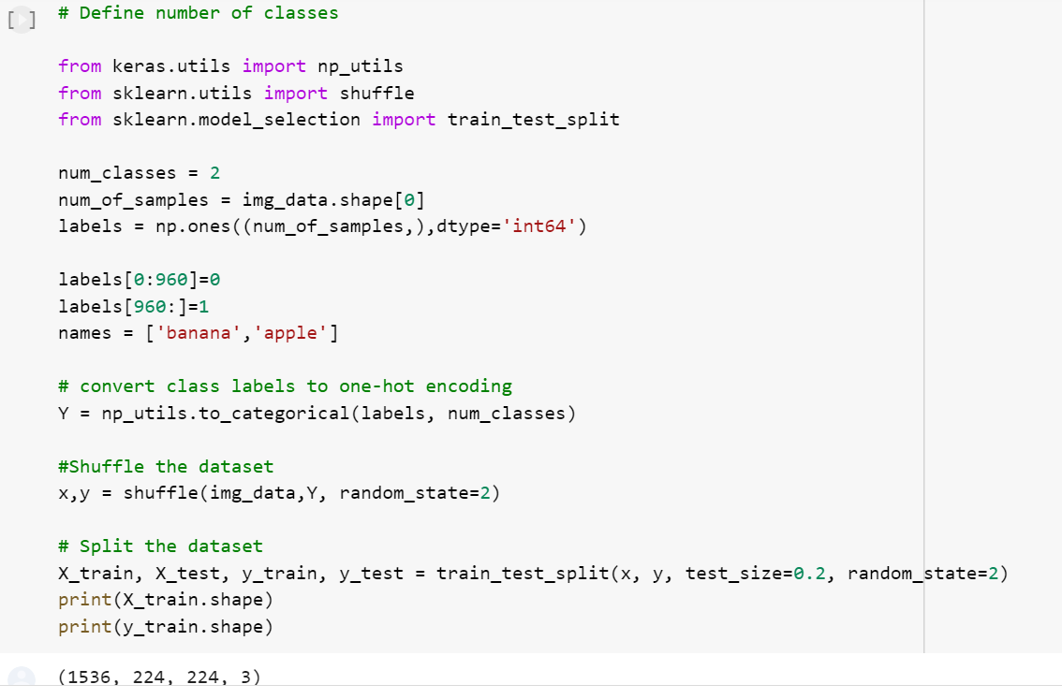

* Since, we have taken only 2 classes apple and banana, we have defined the number of classes as 2
* We converted the class labels to one-hot encoding using np_utils.to_categorical() method
* We then shuffled the dataset and split the dataset into training and testing sets
* Here, we split the dataset by the train/test ratio 80/20

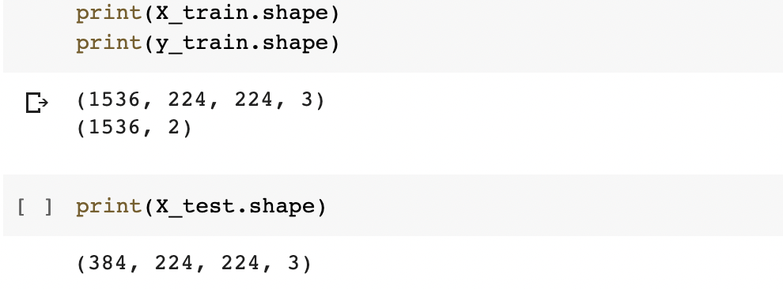

* Since the 1920 images are divided into training and testing sets by the ratio 80/20, the total images in the training set is 1536 and the total images in the testing set is 384

1. **Creating and training the CNN model**

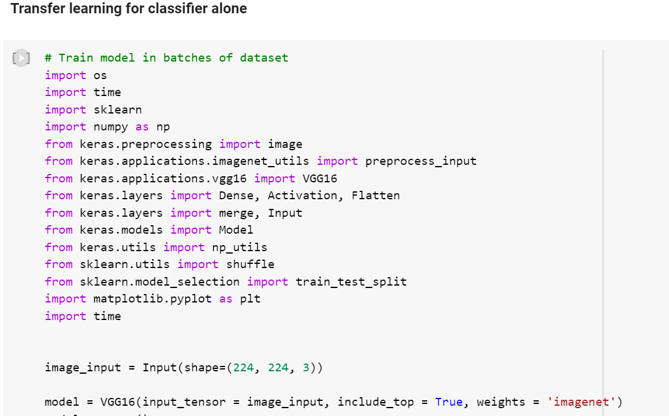

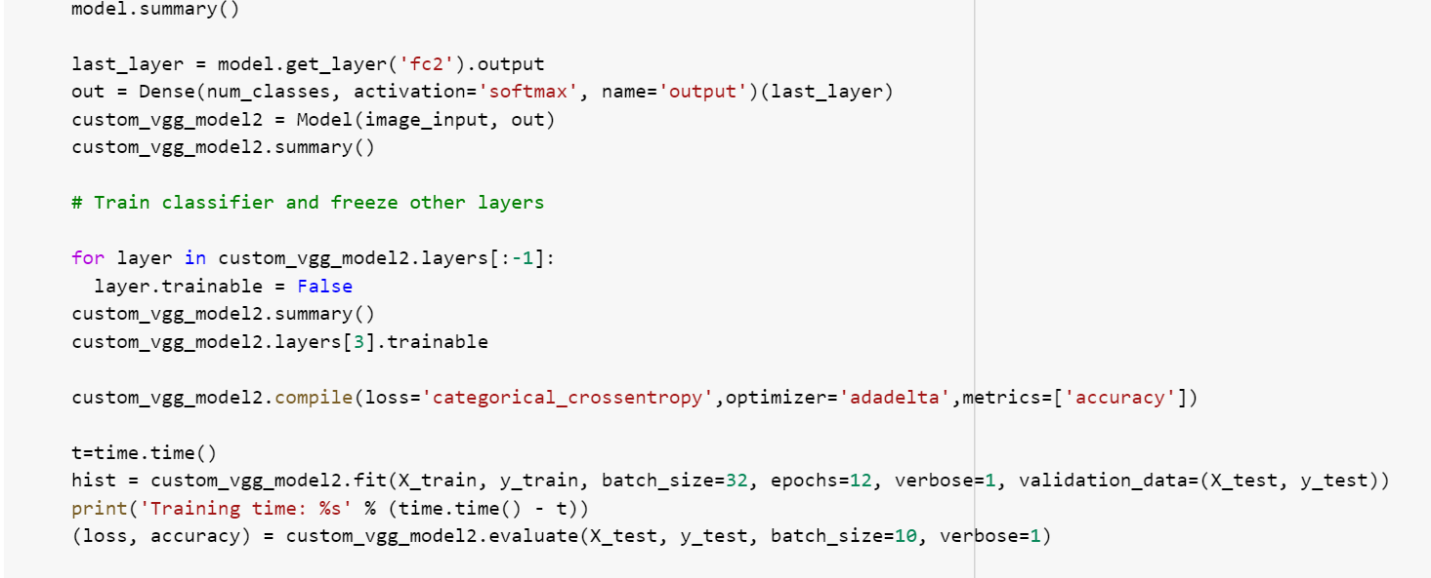

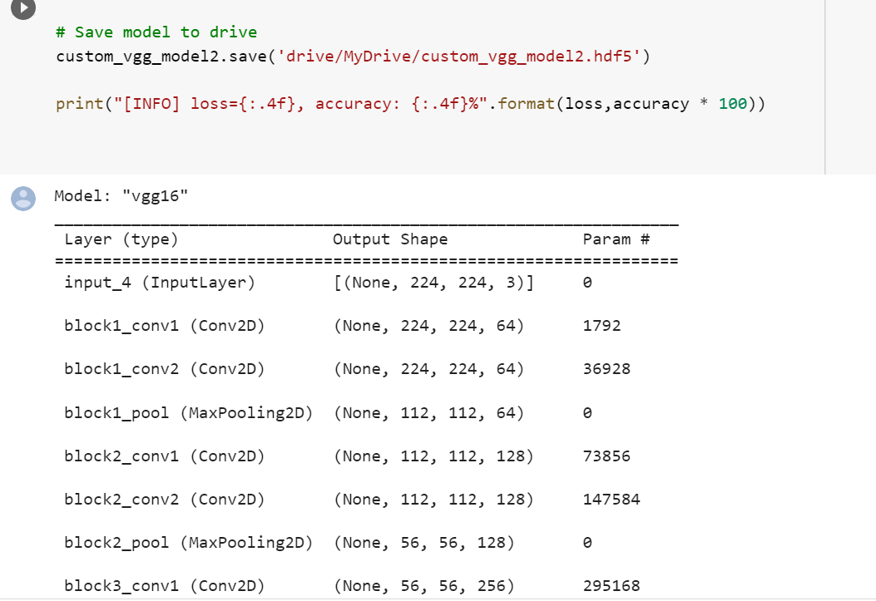

* Here, we used VGG16 pretrained model and applied transfer learning for the classifier alone
* Only the classifier is trained, and all the other layers are freezed
* custom_vgg16_model2.save() is used to save the model to Drive

Below is the summary of VGG16 model:

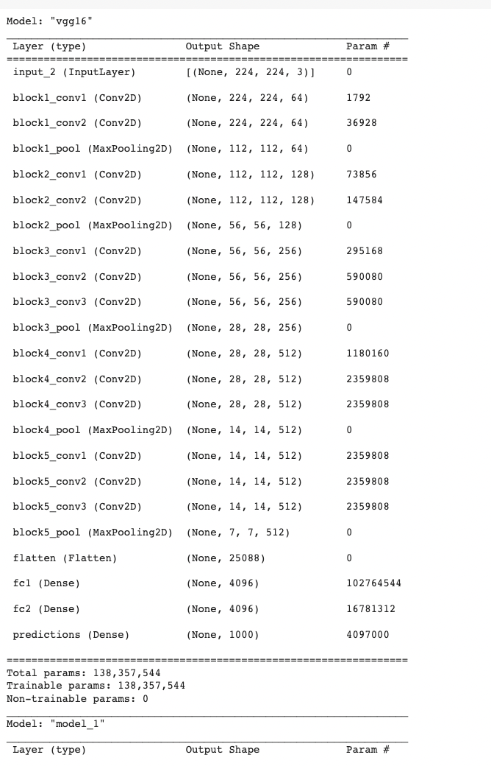

Below is the summary of the custom model after applying transfer learning for the classifier alone:

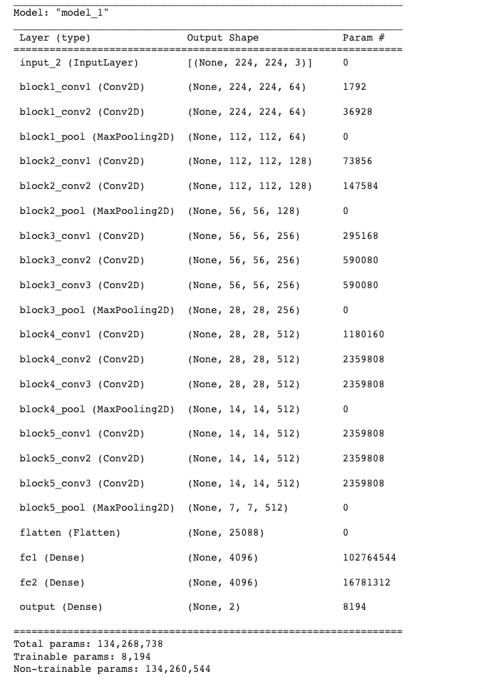

* Since only the classifier is changed, only 8194 params are trainable. Other layers are freezed and the remaining 134,260,544 params are non-trainable.

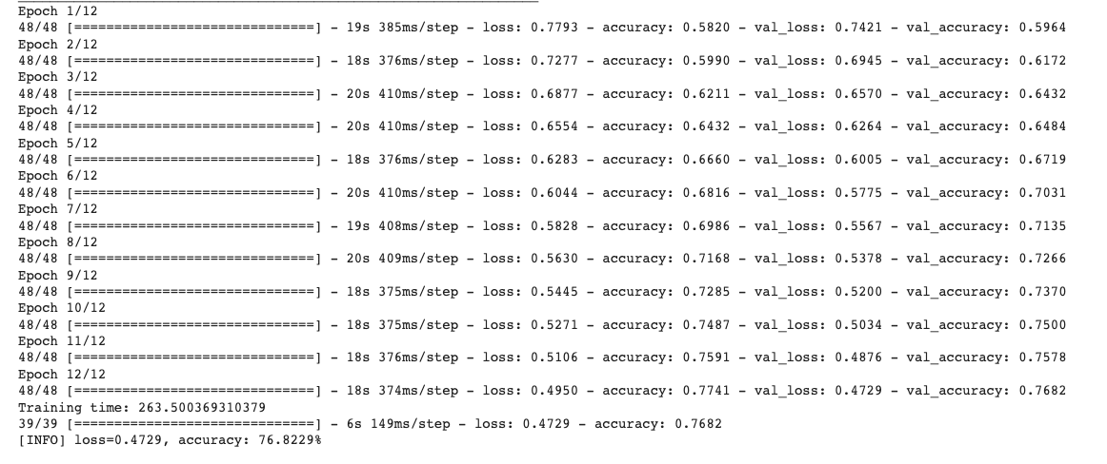

* Here, the accuracy of the model is 76.8229%

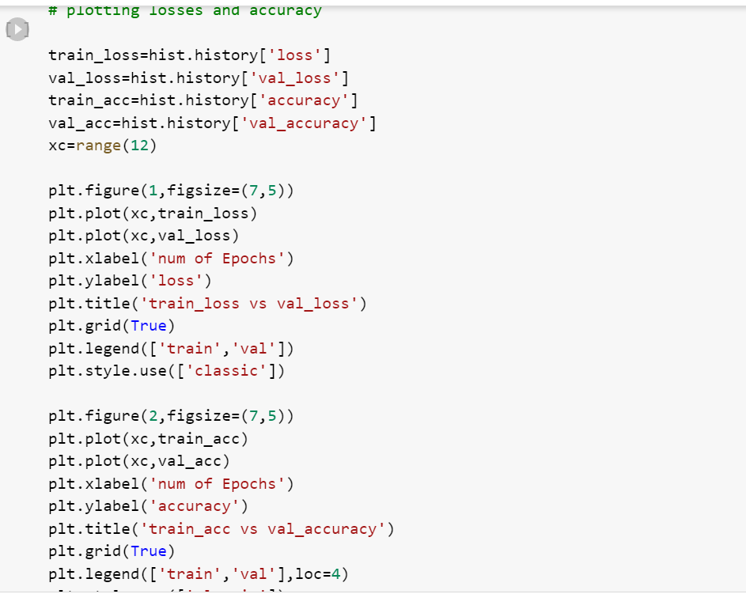

* The above commands are used to plot the train_loss vs val_loss and train_acc vs val_accuracy

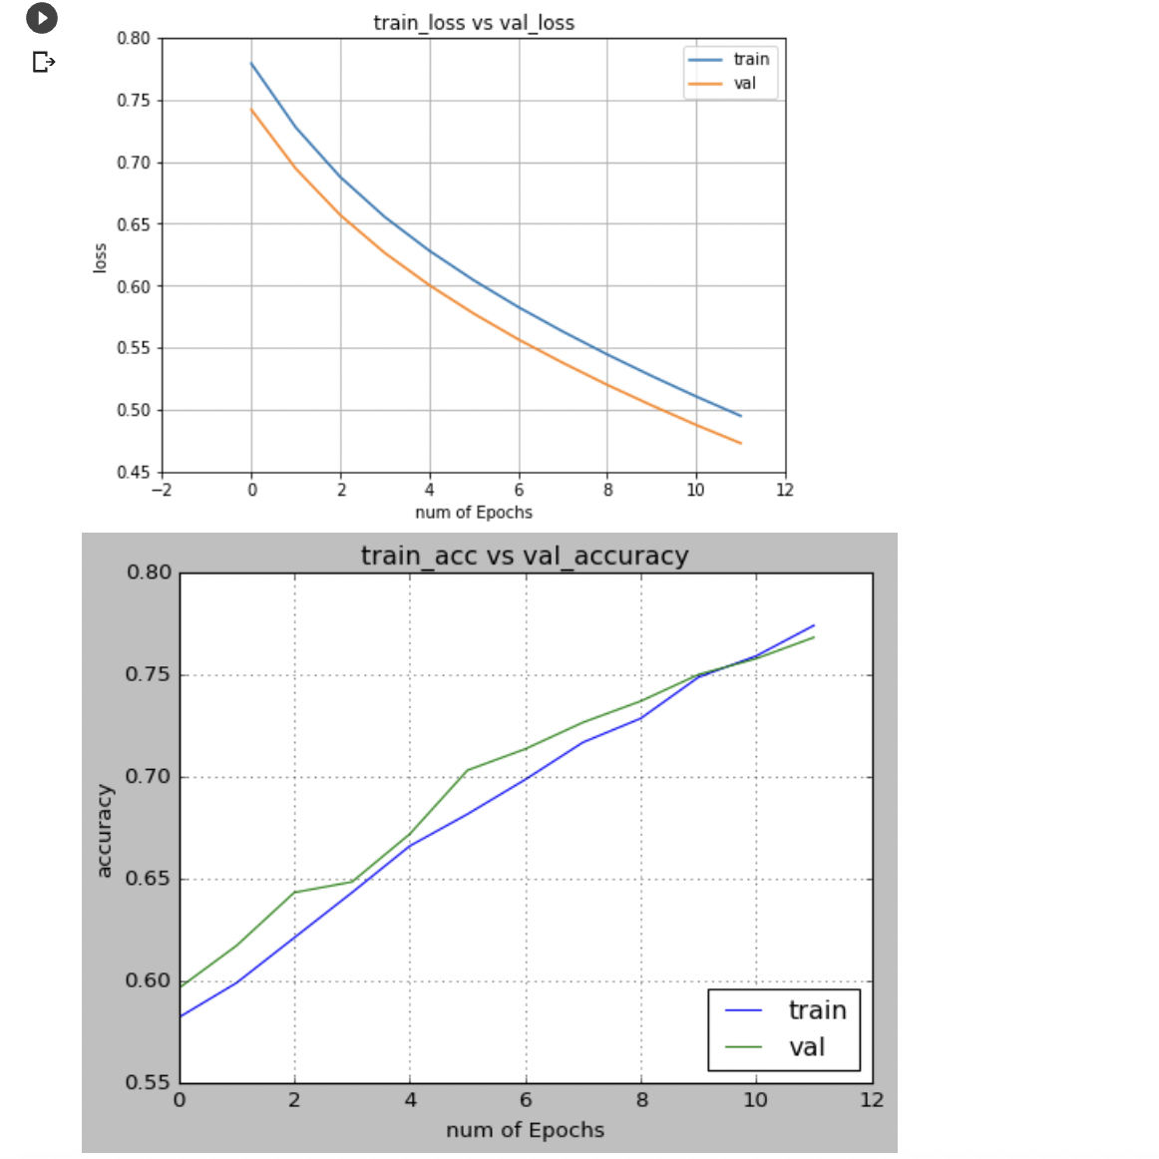

1. **Testing the model**

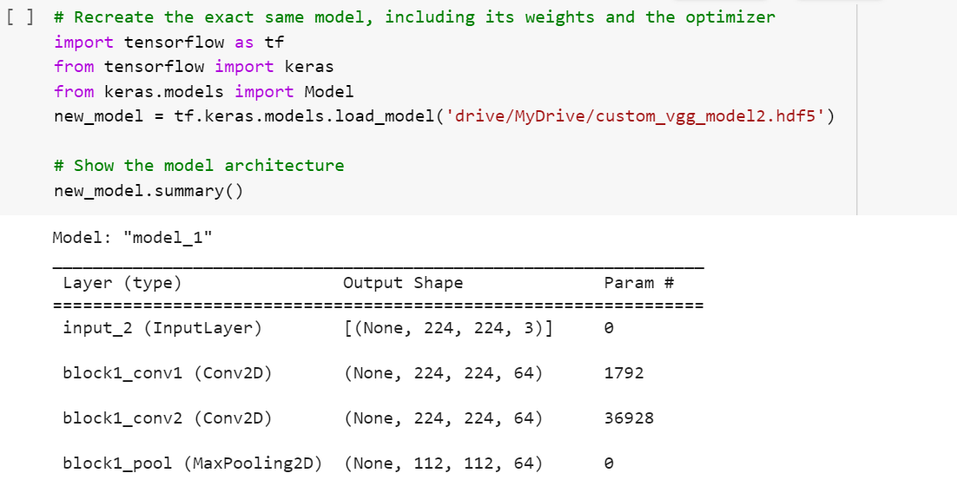

* load_model() from the tf.keras.models.load_model is used to load the saved model from Drive

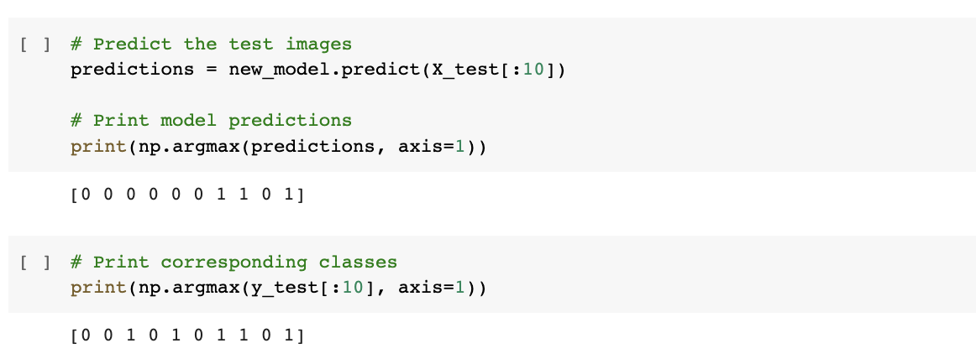

* Here, the model predicted the first 10 images as [0 0 0 0 0 0 1 1 0 1]
* 0 is the label for banana class and 1 is the label for apple class
* But, the actual labels for the test images are [0 0 1 0 1 0 1 1 0 1]
* So, 8 out of 10 test images are predicted correctly

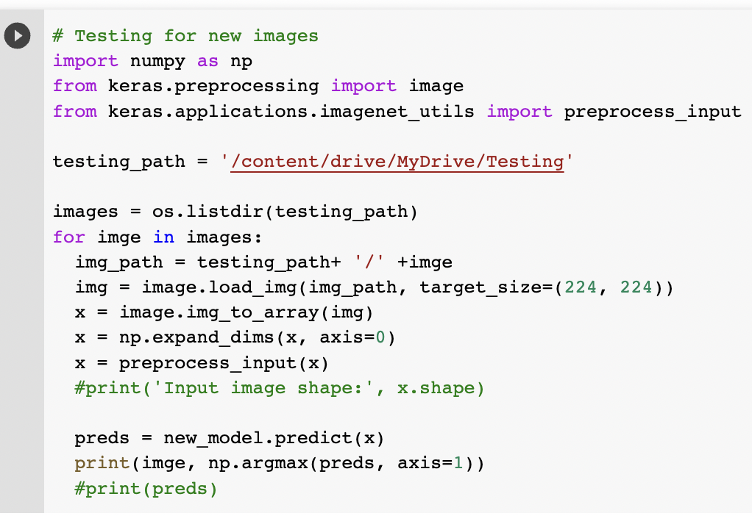

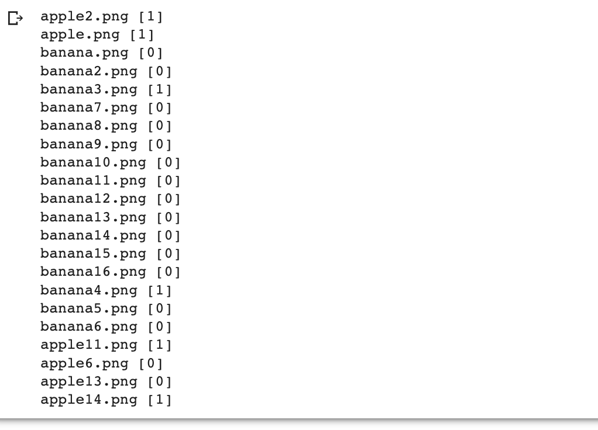

* The correct labels are those for which the model predicts the label as 0 for banana images and te label as 1 for apple images
* So, the model predicted 18 images correctly out of 22 images when the transfer learning is applied only for the classifier alone

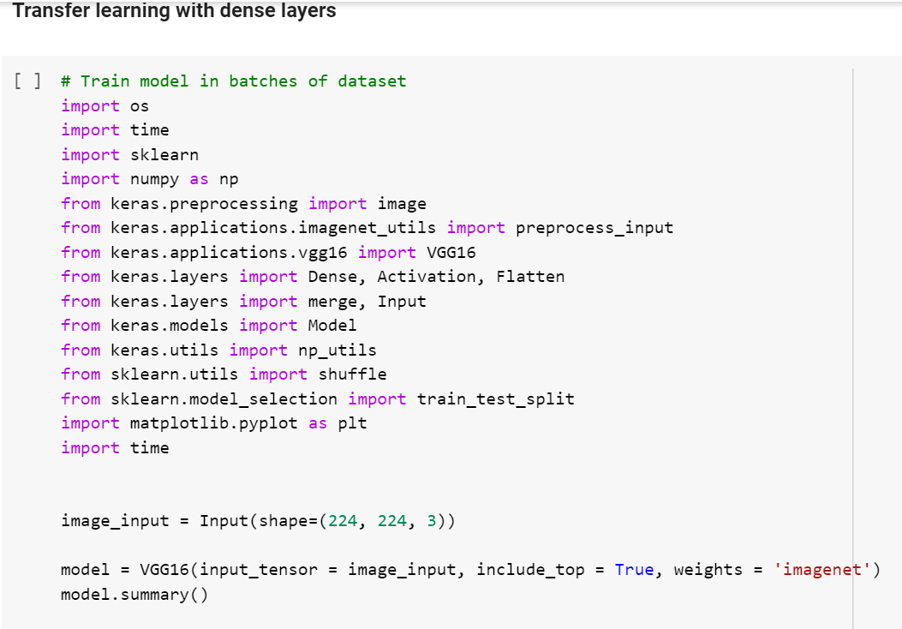

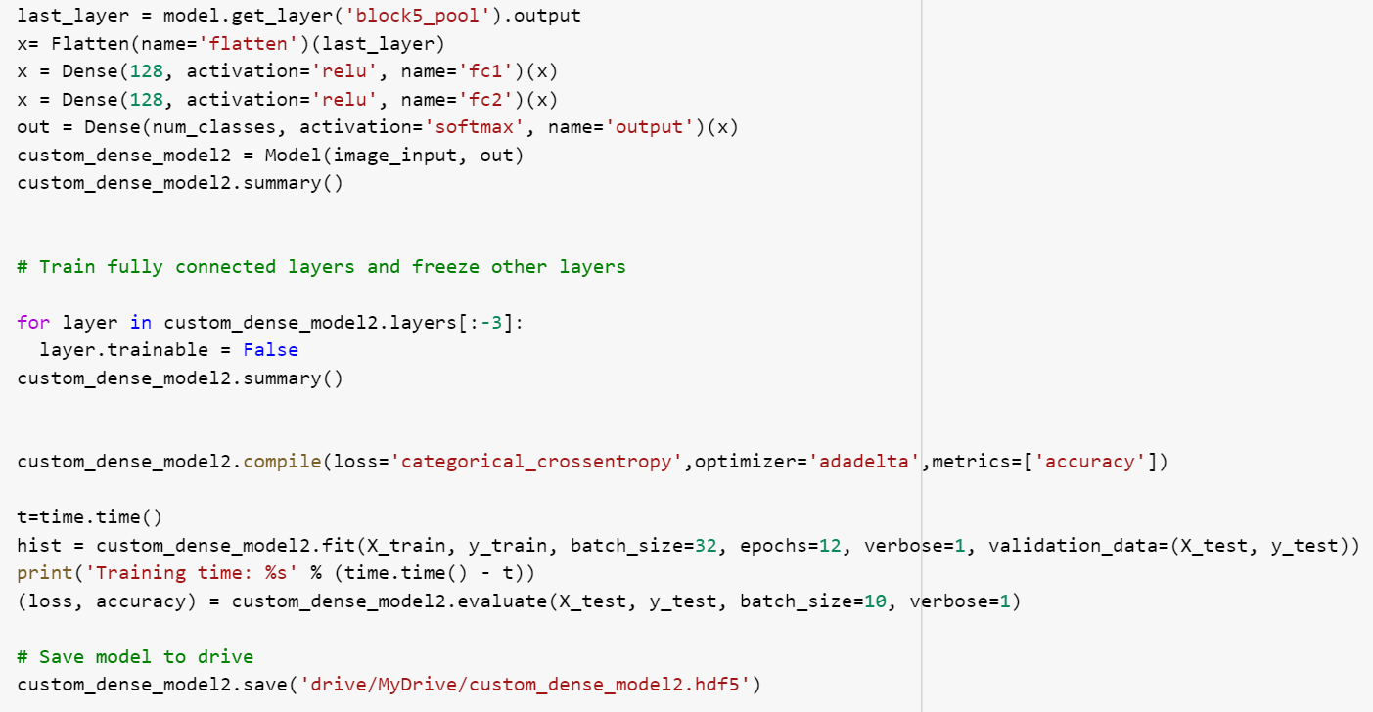

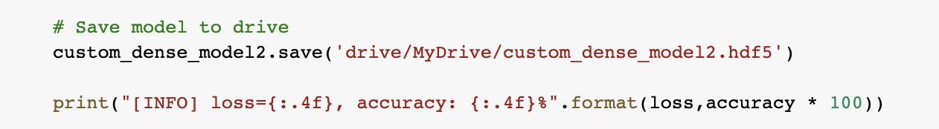

Below is the summary of the custom model when transfer learning is applied for the dense layers

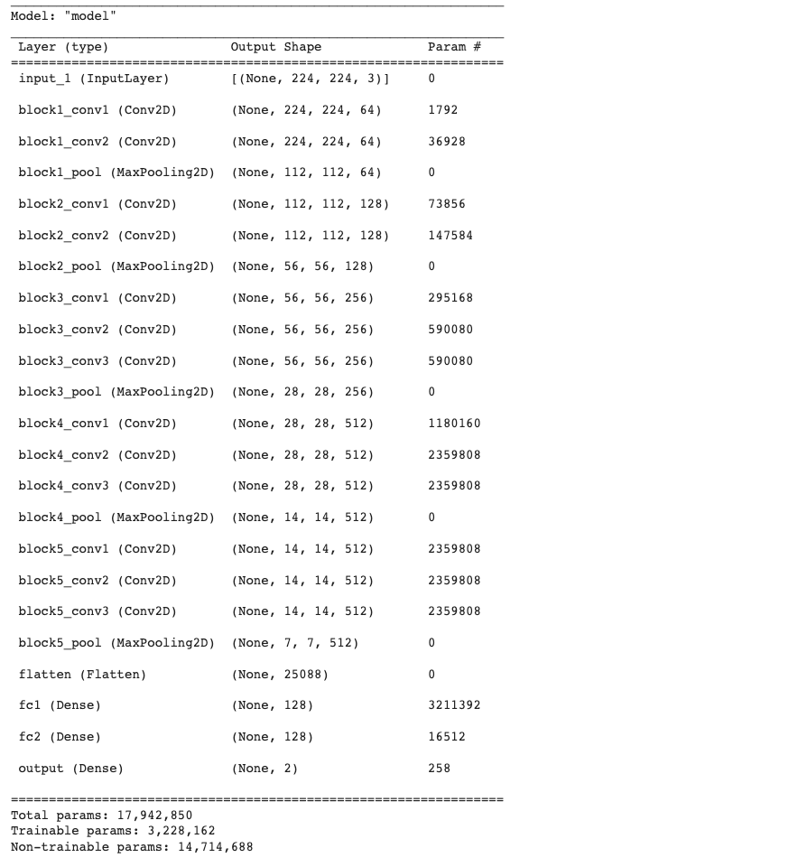

* Since the dense layers along with the classifier are changed, total 3,228,162 params are trainable. Other layers are freezed and the remaining 14,714,688 params are non-trainable.

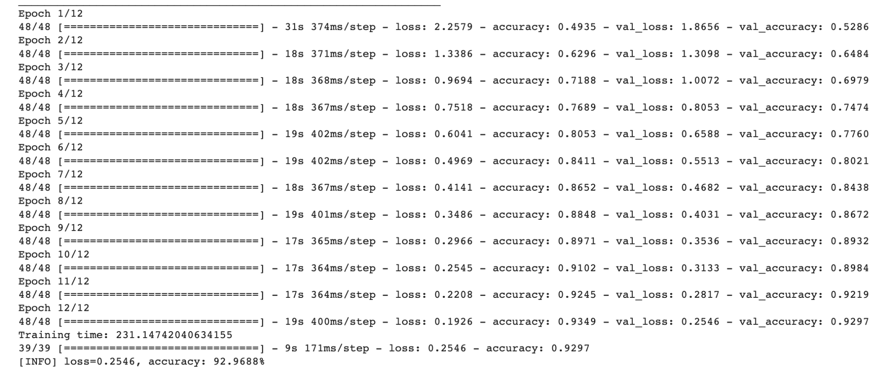

* Here, the accuracy of the model is 92.9688%

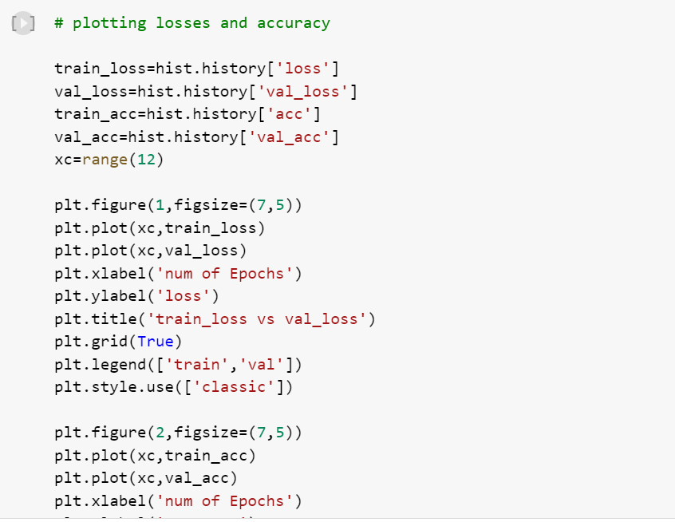

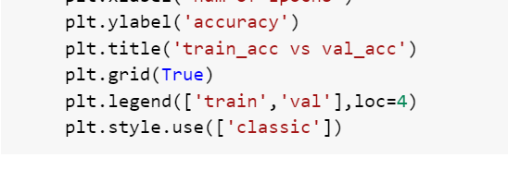

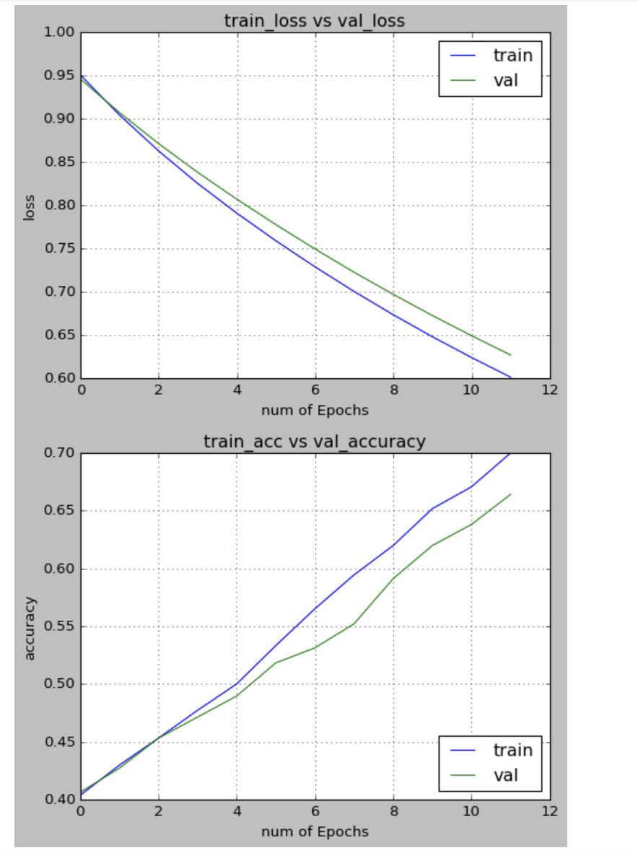

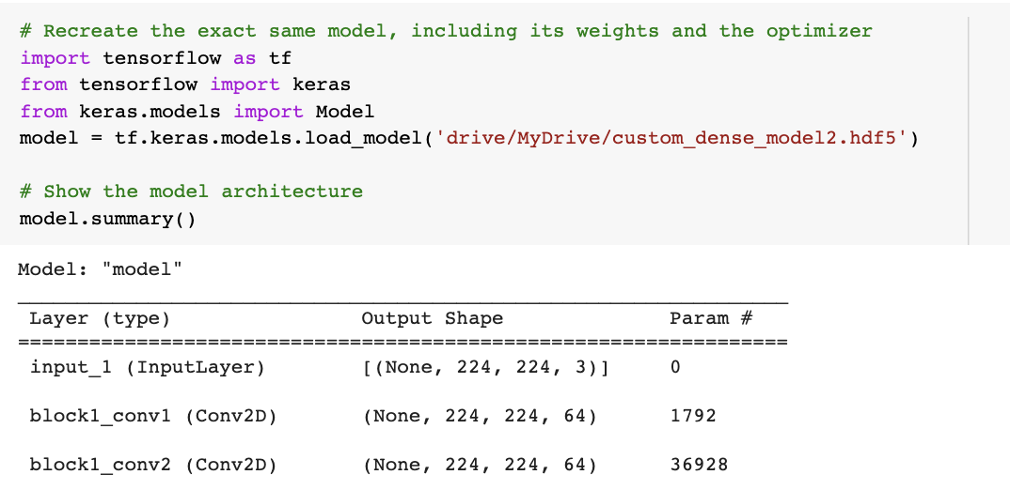

* The saved model is loaded using the load_model() method

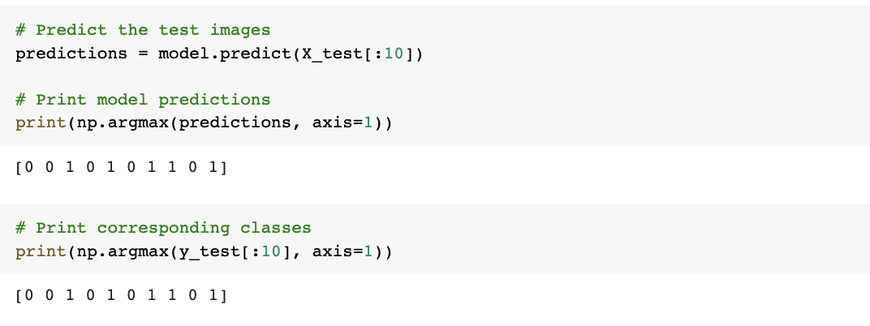

* The model predicted the first 10 images as [0 0 1 0 1 0 1 1 0 1]
* 0 is the label for banana class and 1 is the label for apple class
* The actual labels for the test images are [0 0 1 0 1 0 1 1 0 1]
* Hence, the model predicted the first 10 images of the testing dataset correctly

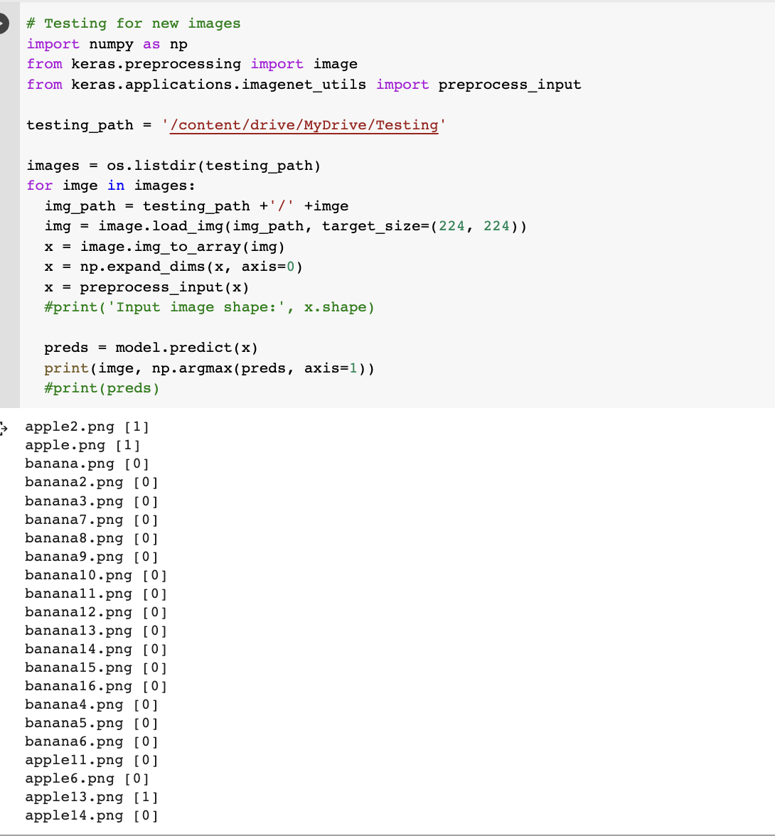

* The correct labels are those for which the model predicts the label as 0 for banana images and the label as 1 for apple images
* So, the model predicted 19 images correctly out of 22 images when the transfer learning is applied for dense layers along with classifier

**Below is the code to train the model for all the 250 classes in the dataset**

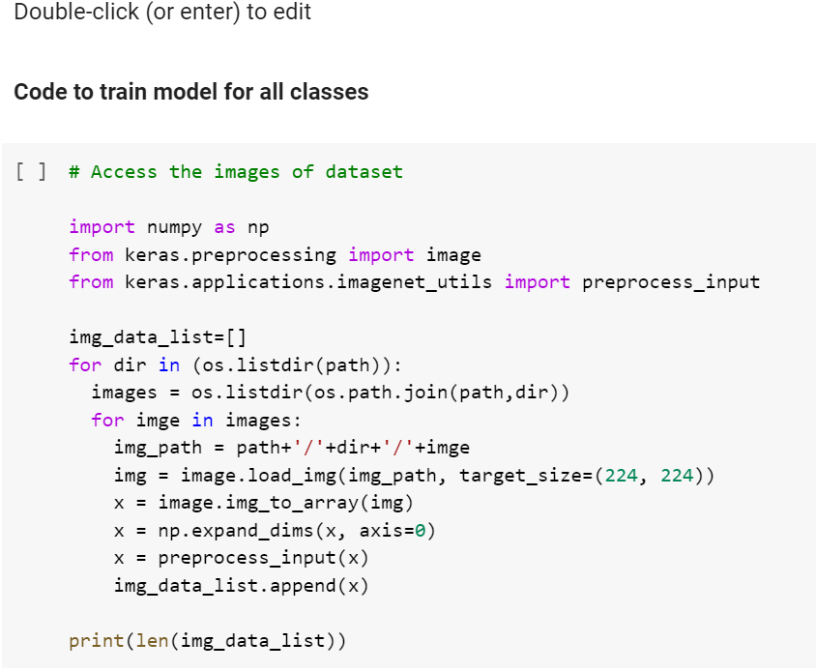

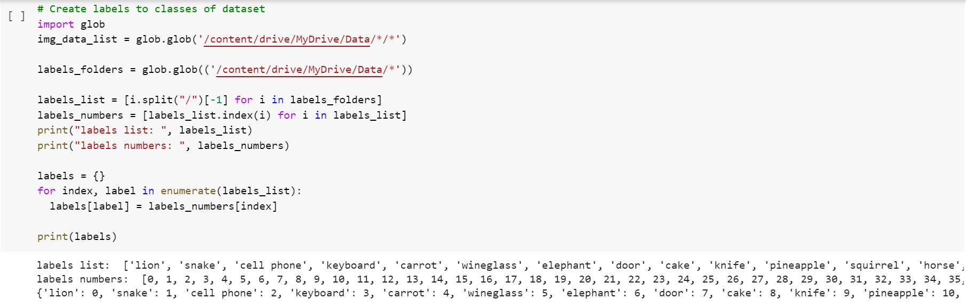

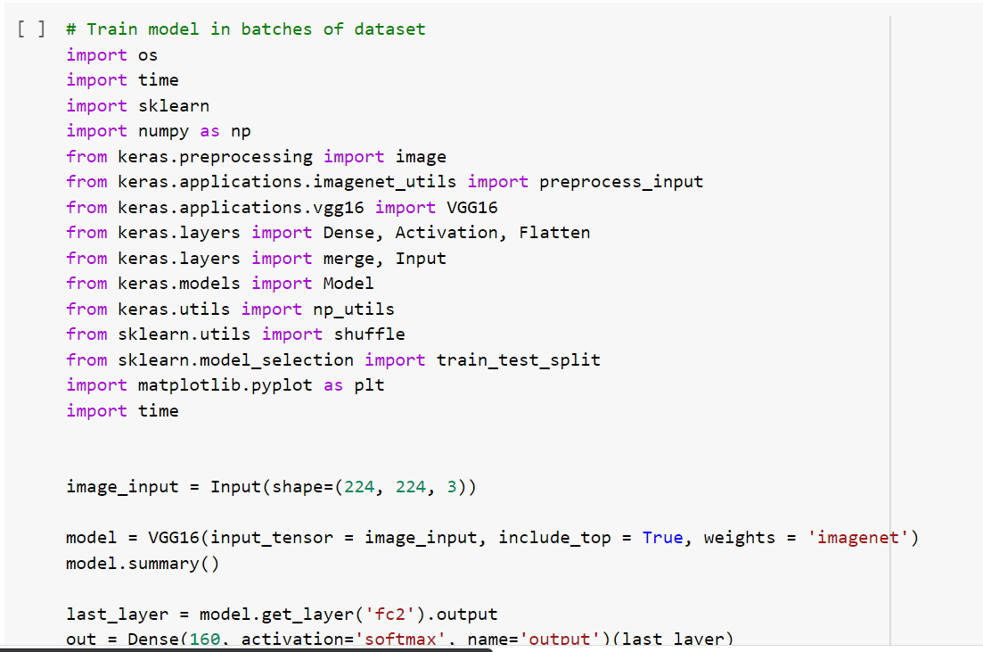

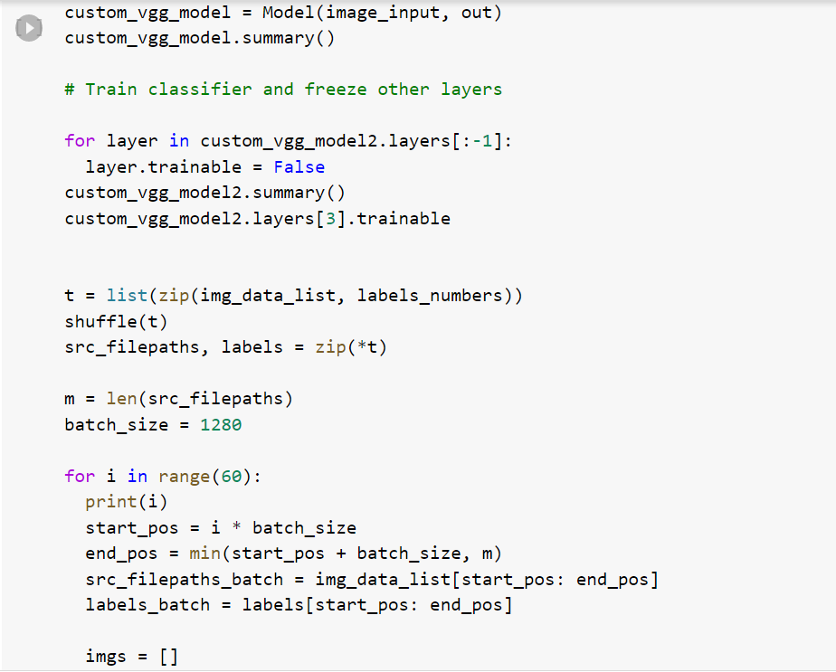

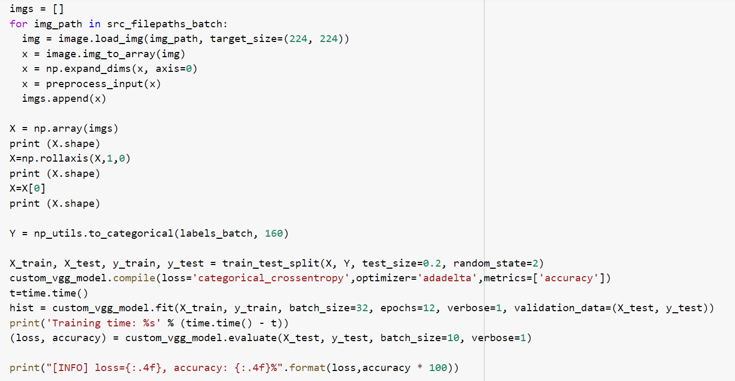

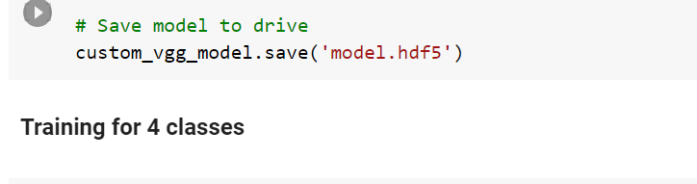

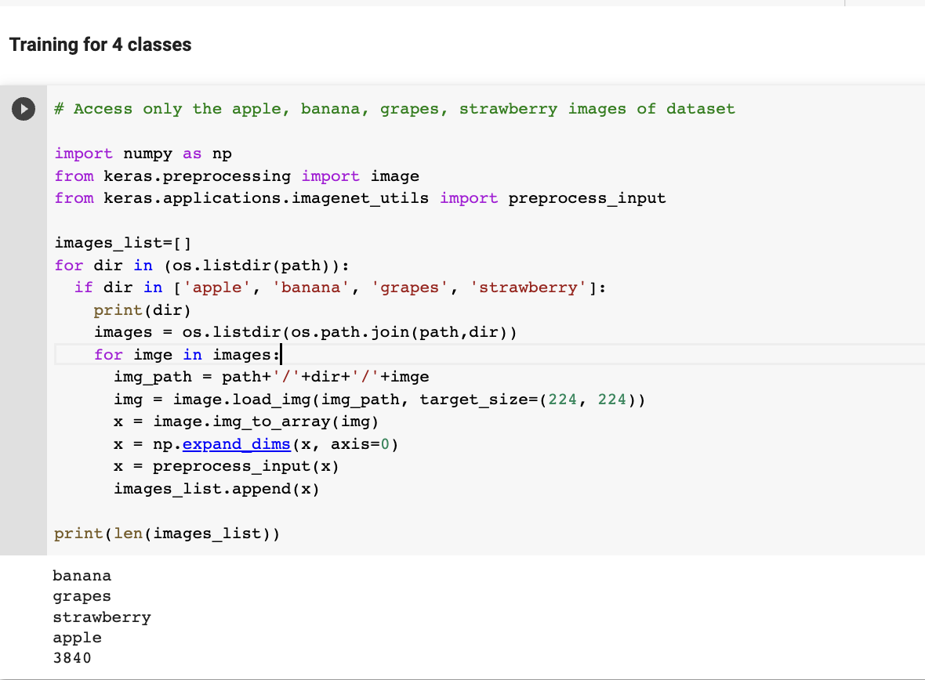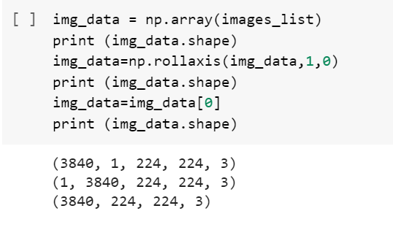

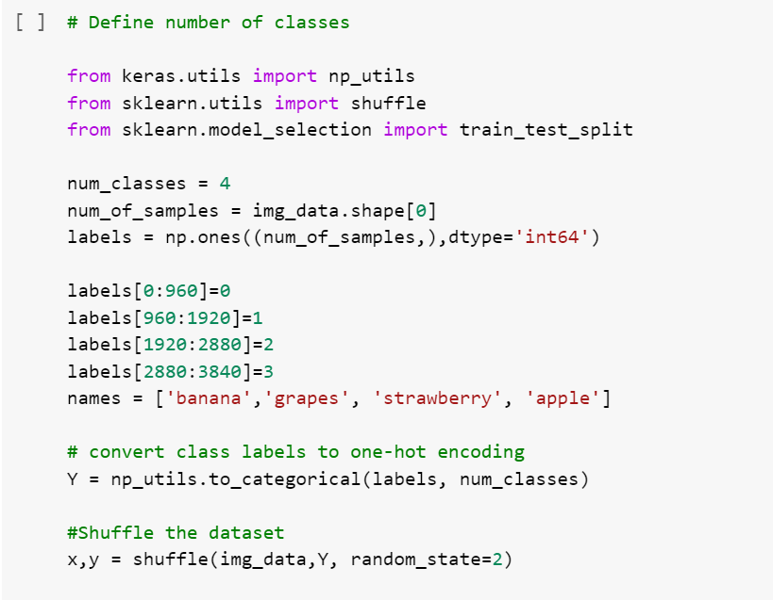

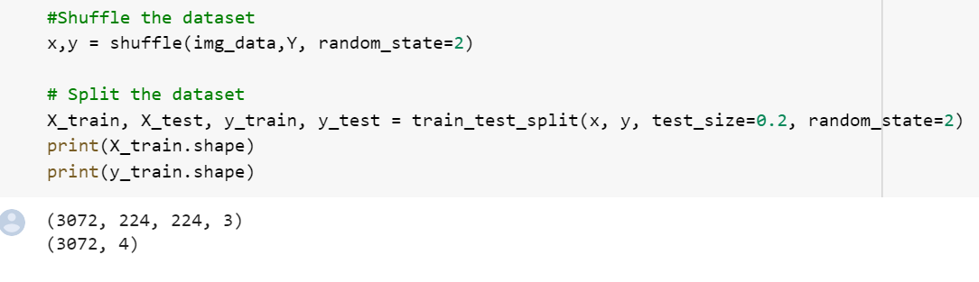

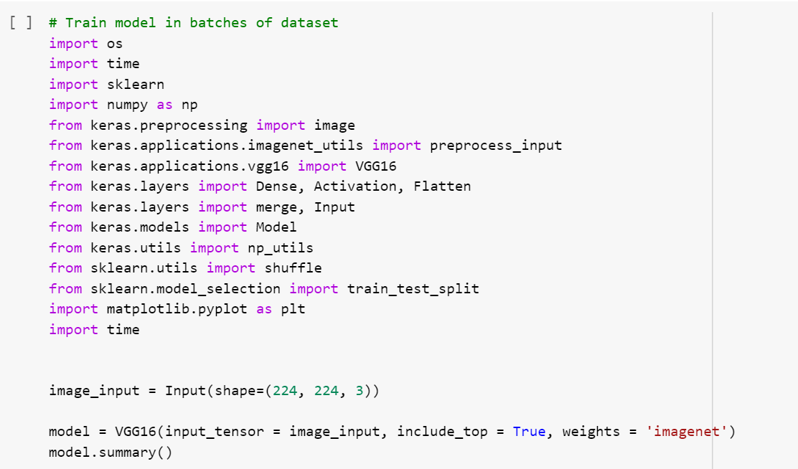

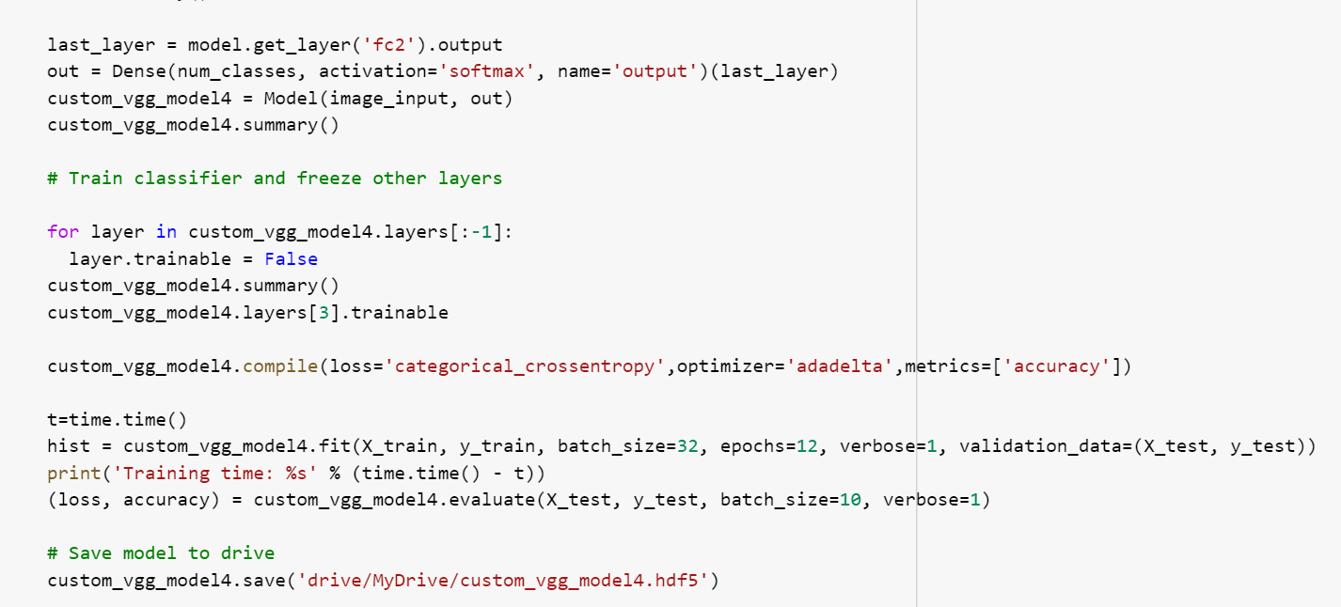

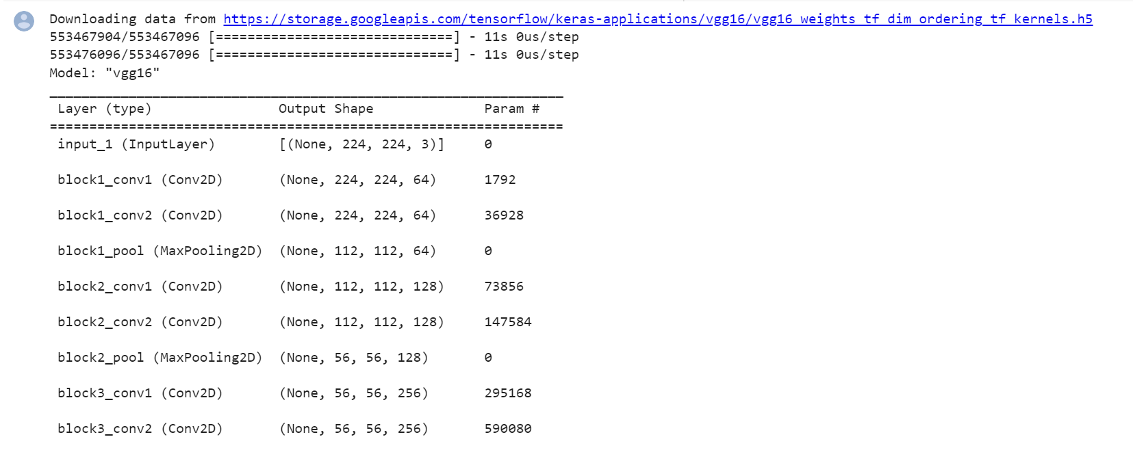

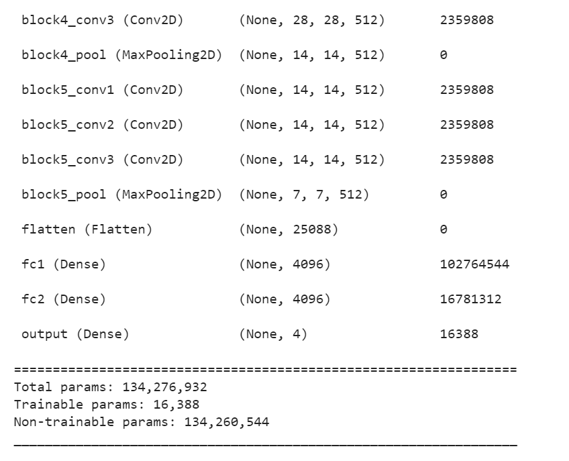

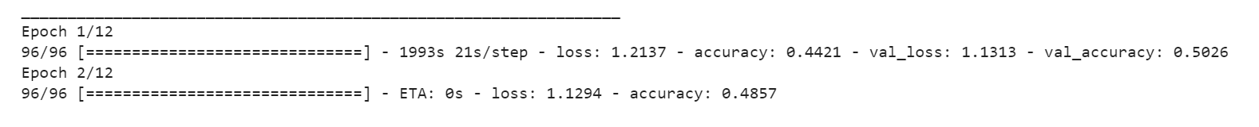

**Conclusion:**

1. We have learnt about Data augmentation techniques like erosion, mirroring, shifting, scaling, rotating etc., and how to implement them in Python
2. We have gained an overview of CNN models and pre-trained models. We have also learnt how to apply transfer learning for a pre-trained model.
3. We have learnt how to use a pre-trained model as a feature extractor and fine tuning the model.
4. We have also learnt how to train the model and predict the labels for the test dataset using the dataset and compare it with the corresponding ground truths.

**Challenges:**

1. Free-hand sketches are usually drawn by non-artists using touch sensitive devices rather than purpose-made equipment; thus, making them often highly abstract and exhibit large intraclass deformations. This makes automatic recognition of sketches more challenging than other areas of image classification because sketches of the same object can vary based on artistic style and drawing ability.
2. In addition, sketches are less detailed and thus harder to distinguish than photographs.
3. We have tried training the model for the entire dataset, but the computing resources were insufficient. The RAM available in Google Colab was not enough to perform the operation and the session kept crashing.
4. So, we trained the model for two classes (apple and banana) by using VGG16 model and applying transfer learning to it
5. Later, we tried for four classes, but the RAM was insufficient. We have tried running it in GPU and TPU, but the resources were still not enough.
6. So, the current model can recognize the given sketch as either apple or banana

**References:**

1. <https://cybertron.cg.tu-berlin.de/eitz/projects/classifysketch/>
2. <http://cybertron.cg.tu-berlin.de/eitz/pdf/2012_siggraph_classifysketch.pdf>
3. <http://cvgl.stanford.edu/teaching/cs231a_winter1415/prev/projects/final_report.pdf>
4. <https://iui.ku.edu.tr/sezgin_publications/2017/SezginYesilbek-CG-2017.pdf>
5. <http://cs231n.stanford.edu/reports/2017/pdfs/420.pdf>